San Luis Valley BOCES Alternative Licensure Handbook

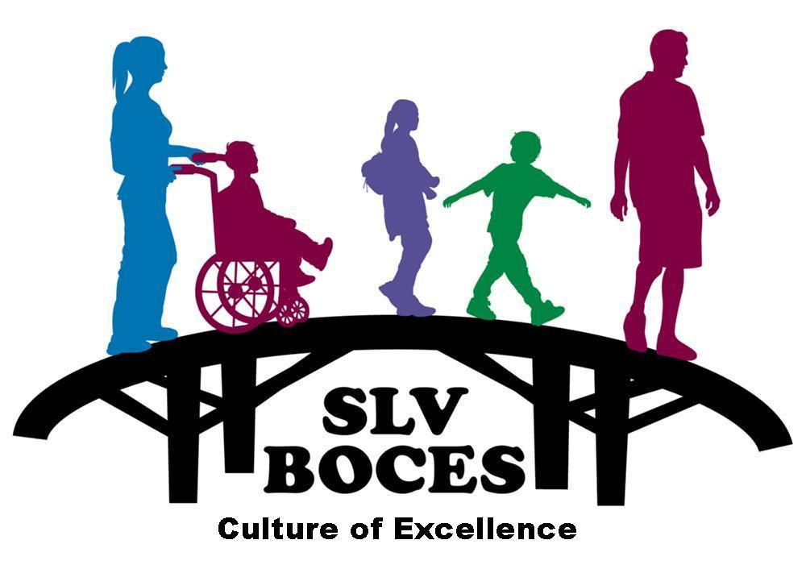

A Regional Education Agency

2261 Enterprise Dr.  Alamosa, CO  81101  (719) 589-5851

www.slvboces.org

Alternative Licensure Program Handbook
(Teacher)

2020-2021

Purpose of Alternative Licensure
The State Board of Education can allow Designated Agencies to create one-year and two-year alternative teacher programs to assist districts and BOCES that face a shortage of teachers and often struggle to find qualified persons to teach their students (State Statute 22-60.5-205 and the Educator Licensing Act Rules). Such programs shall:

- Decrease the use of emergency authorizations to hire persons who do not have teacher licenses and, in some cases, have not received any form of teacher preparation thus jeopardizing a school district's goal of providing a quality education for each student; and

- Identify persons with experience in areas other than education to help alleviate the teacher shortage faced by many school districts, so long as these persons receive adequate supervision and education in teaching methods and practices.

School District(s), BOCES, regionally accredited Institutes of Higher Education or nonprofit organizations can serve as a Designated Agency in Colorado (State Statute 22-60.5-102 [10] and 22-60.5-205 [2]). Any of these entities may partner or collaborate for the operation of an approved alternative teacher program. A district or BOCES may choose to contract with an Institute of Higher Education that already provides an approved teacher preparation program. An individual’s successful completion of an alternative teacher preparation program leads to a recommendation for initial licensure by the Designated Agency providing the program.

State Statute 22-60.5 was intended to address teacher shortages in public schools. Designated Agencies must serve an identified need(s) of a Colorado school district(s) or BOCES. Designated Agencies can create alternative preparation programs in numerous teacher endorsements areas. State Statute does not allow alternative licensure pathways for Specialized Service Professionals.

Goals
The goal of the San Luis Valley BOCES alternative teacher licensure program is to increase access to effective teachers for all students in the San Luis Valley BOCES region, supporting the San Luis Valley BOCES mission: “Through collaboration with member districts, the SLV BOCES is the bridge to excellence in education. The SLV BOCES serves schools, families, and communities of the SLV by providing service, support, and leadership to promote student achievement and success in life for all.” The alternative teacher licensure program will accomplish this goal by:
- providing a resource for schools to place alternatively-license teachers in hard-to-fill positions
- supporting alternatively-licensed teachers in developing the knowledge and skills they need to become successful educators
- providing the types of supports for teachers that have been proven to increase retention including:
  - content on the best practices that are most critical to success in the first 3 years of teaching
  - a professional network that includes both veteran colleagues and other new teachers, locally and regionally
- designing and continually refining a program that meets the indicators from the state of Colorado for an alternative licensure program
- facilitating activities that help new teachers to reflect, apply learning, and make continuous progress on a journey toward masterful teaching.

Alternative Teacher Licensure Program and Requirements
The Alternative Teacher Licensure Program is a state approved non-traditional licensure program offered by San Luis Valley BOCES to eligible candidates only (see Eligibility Requirements below). This program is designed for the individual who would like to become a licensed teacher in Colorado but has not completed a traditional teacher licensure program through a college or university. The program is a one-year “on-the-job” teacher preparation training experience. Please visit CDE’s website for possible teaching/endorsement areas: http://www.cde.state.co.us/cdeprof/Licensure_alt_endorsements.asp

Eligibility Requirements
A candidate must meet the following requirements in order to enroll in the Alternative Licensure Program (ALP):
- Hold a minimum of a Bachelor’s degree
- Secure a full-time teaching contract in the appropriate teaching/endorsement area with one of the following public-school districts within the San Luis Valley BOCES region: Alamosa, Centennial, Center, Creede, Moffat, Monte Vista, Mountain Valley, North Conejos, Sanford, Sangre De Cristo, Sargent, Sierra Grande, South Conejos and Upper Rio Grande.
- Complete an alternative license application with CDE online and receive an alternative license from CDE for the appropriate teaching/endorsement area by September 30th in order to complete the Alternative Licensure Program requirements that school year
- As part of the alternative license application process, CDE will need to verify that the candidate has either:
- Documented evidence of 24 semester hours of college level coursework for the teaching/endorsement area they are employed in from a regionally accredited college or university; OR
- A passing score on the approved nationwide PRAXIS II test.

CDE Application Process
Any individuals who are interested in pursuing alternative licensure are encouraged to visit the CDE website at any time to learn more about the CDE application process – starting the license application early (i.e. before applying for teaching positions) and being informed on eligibility requirements will improve your chances of being hired by a school district.

Please note that ALP candidates are fully responsible to apply for and be granted an alternative license from CDE. This is a detailed process with multiple steps and candidates should allow for CDE processing time of approx. 4 weeks for a complete application.

Here is a link to CDE’s Educator Licensing Department: http://www.cde.state.co.us/cdeprof. Please review all of the relevant information on the website. You can also call the customer service line at (303) 866-6628 with any questions that you may have.

Notification to San Luis Valley BOCES
After securing a teaching position, the candidate and/or the employing school district must notify San Luis Valley BOCES upon hiring and no later than August 31st to be able to start the program in the fall. The candidate will need to sign the Alternative Licensure MOU Agreement, complete the Statement of Assurance of Employment form required by the Colorado Dept. of Education and complete online the Alternative Licensure application. Both of these forms will require the candidate to obtain a district signature and the signature of the San Luis Valley BOCES Executive Director. As soon as the candidate has received their alternative license from CDE, they will need to provide a copy to the San Luis Valley BOCES Executive Director and their school district.

San Luis Valley BOCES ALP Program Fees
Candidates in member districts only: $3,800
( Alamosa, `Centennial, Center, Creede, Upper Rio Grande, Moffat, Monte Vista, Mountain Valley, North Conejos Sanford, Sangre De Cristo, Sargent, Sierra Grande, and South Conejos)

Alternative teachers are paid a salary by their hiring school district. Salary schedules vary by district and can be found on school district websites.

San Luis Valley BOCES program fees are the responsibility of the candidate, and will be collected by district payroll deduction.
- The Teacher will be responsible for the full registration fee of $3,800, whether or not the teacher completes the program, or CDE refuses to grant a license.
- The Teacher will allow the District to payroll deduct the registration fee from the Teacher’s salary on terms to be agreed upon by the Teacher and the District.
- The District will pay the San Luis Valley BOCES the full registration fee of $3,800. The District can elect to pay the full registration fee upon billing; or in semi-annual payments by October and February: or monthly as the fee is recovered from the employee.

All charges payable for fingerprints, tests and applications to CDE are paid directly by the candidate.

Program Contact
Please contact the San Luis Valley BOCES Executive Director for any questions relating to the BOCES alternative licensure program.

Tina Goar
Executive Director, NW BOCES
2261 Enterprise Drive
Alamosa, CO 81101
Office: 719-587-5417
Cell: 970-846-4331
Fax: 719-589-5007
tgoar@slvboces.org

Questions on CDE’s alternative teacher license application should be directed to CDE.

Program Content/Completion
In order to be recommended for an initial teaching license, alternative licensure candidates must successfully complete the program requirements, which include:

- 225 clock hours of training including:
  - Online Estimated Hours (70 hours)
  - Observations and Visitations (25 hours)
  - Mentoring (40 hours)
  - Staff and School Meetings (20 hours)
  - School District/ Valley Professional Learning (40 hours)
  - BOCES Seminars (40 hours)
- Classroom Instruction That Works by McREL will be incorporated into the professional learning and seminar requirements.
- Professional Reading will be incorporated into the professional learning and seminar requirements.

Once the candidate has passed the portfolio review, completed all program requirements and full payment of fees has been made, San Luis Valley BOCES will issue a Verification of Completion form for Initial Teacher Licensure that the candidate will need to submit to CDE online.

The program content required for completion includes the following:

Online Estimated Hours (Subject to Revisions)

English Language Learners- Must complete 65 hours of Estimated Effort.
This collection is designed to provide teachers the practical tools to help their English language learners (ELLs) succeed. Created by the Understanding Language Initiative at Stanford University, these courses focus on the language-rich performance expectations that all students must meet: obtaining, evaluating, and communicating information; articulating and building ideas; constructing explanations; and engaging in evidence-based argumentation. Additional workshops available in this library were developed by WestEd.

AR211: Improving Argumentation Skills through Formative Assessment Practices
ELL108.1E: Mastering Math Language Part I: Reading and Speaking (K-5)
ELL108.2E: Mastering Math Language Part II: Conversations and Writing (K-5
ELL212E: Constructive Classroom Conversations (K-5)
ELL212M: Constructive Classroom Conversations (6-8)
ELL212H: Constructive Classroom Conversations (9-12)
ELL311: Communication-Focused Conversation
ELL312: Communication-Focused Listening & Watching
ELL313: Communication-Focused Speaking
ELL314: Communication-Focused Reading & Visual Literacy
ELL315: Communication-Focused Writing
ELL411: Coaching for Communication-Focused Conversation
ELL412: Coaching for Communication-Focused Listening & Watching
ELL413: Coaching for Communication-Focused Speaking
ELL414: Coaching for Communication-Focused Reading
ELL415: Coaching for Communication-Focused Writing
ELL511: Establishing a Culture of Conversation in the Classroom
ELL512: Creating Effective Conversations, Prompts, and Tasks
ELL513: Preparing for Effective and Efficient Formative Assessments of Conversations
POW317: Vocabulary Instruction for English Language Learners (ELL)
POW329: Engaging Students in Meaningful Text Discussions
POW125: Universal Design for English Language Learners
POW324: Intervention for Struggling Readers

Special Education – Must complete 25 hours of Estimated Effort.
Our Special Education library provides practical courses and workshops designed to meet the unique PD needs of teachers and support staff. Courses in this collection were exclusively developed by special education experts at WestEd, Public Consulting Group, and CHADD. Topics include: collaborative teaching to support inclusive education, co-teaching and special education differentiation, writing standards-based IEPs, Universal Design for Learning, and supporting students with ADHD.

P2P: Parent to Parent: Family Training on ADHD
P2PM1: Introduction to ADHD (Parents and Families)
P2PM2: Probable Causes & Assessment for ADHD
P2PM3: Supporting Your Child at School
P2PM4: Creating an ADHD Friendly Home Environment
P2PM5: Comprehensive Treatment of ADHD
POW110: Universal Design for Math Learning
POW111: Universal Design for ELA Learning
POW112: Universal Design for Science Learning
POW125: Universal Design for English Language Learners
POW210: Elements of Differentiated Instruction
SE104: Collaborative Practices that Support Inclusive Education
SE112: Co-Teaching: Special Education Differentiation
SE211: Strategies for Making Differentiated Instruction Work
SE215: Writing Standards-Based IEPs
SE221: Effective Paraprofessionals
SE310: Supporting Students with Disabilities in Language Arts
SE311: Supporting Students with Disabilities in Mathematics
SE501: Individuals with Disabilities Education Act Essentials
SE502: Evaluation and Eligibility
SE503: Early Intervention (EIS)
SE504: Least Restrictive Environment
SE505: Family Educational Rights (FERPA) and Confidentiality
SE506: Discipline and Manifestation Determination
SE507: Individualized Education Program (IEP)
T2T: Teacher to Teacher: Supporting Students with ADHD

To guide your Pace this means you should have the following Estimated Effort per month.
Sept- 10
Oct- 10
Nov. 10
Dec. 0 (catch up time)
Jan.-10
February- 10
March- 10
April -10
May 0 (catch up time)

Total: 70 hours

BOCES Seminars/Bi-Monthly virtual meetings
(Subject to Revisions)

Classroom Instruction That Works by McREL. Nine research-based categories of
Instructional strategies and relevant classroom practices are presented, discussed and practiced
in the classroom.

Introduction to Educational Leadership (Initial Registration Overview), Standard IV
Mentor teachers should attend. This seminar will address program requirements and expectations, and setting up observations/portfolios. As future educational leaders, we must first understand and be able to identify sound educational practices. Make sure you invite your Mentor so they can support you in the right way.

Critical Elements of a Comprehensive Literacy Curriculum, Standard I
In this seminar we will cover the five components of reading, as outlined by the National Reading Panel. We will discuss how literacy skills can be incorporated into other content areas through various instructional strategies. Math literacy will also be discussed. Overview of the Colorado Reading to Ensure Academic Development Act (READ Act). This will support needed reflection in portfolio.

Critical Elements of a Comprehensive Math Curriculum, Standard I
In this seminar we will cover critical elements of best practices in math instruction. We will discuss how math skills can be incorporated into other content area. Math literacy will also be discussed. This will support needed reflection in portfolio.

Conversations with Model Teachers in the Field, All Standards
This seminar will be a workshop for all candidates to discuss best practices and instructional strategies with model teachers from the field. Model teachers who have represented the Valley as outstanding educators or mentors will be present to answer questions of best practices for candidates. This is also an opportunity for individualized assistance on any educational topic of concern. (TQS I-V) Class discussion of candidate submitted topics will occur.

Instructional Queries Around Behavioral Expectations, Standard II and III
This seminar will deal with best practices in K-12 education. How we can handle behavioral concerns and creating a culture of safety and growth.

Multi-tiered System of Support (MTSS), Standards II and III
This seminar will deal with systems for student success. A brief background of special education law will be given. Various methods of modifications and accommodations for at-risk learners will also be included. Ideas, for formative assessment and check for understanding will be introduced.

Quality Standard I-IV: Maximizing the Modern Learner, All Standards
This will be the final individualized seminar, offering guidance for each candidate on relevant topics. Program input from candidates is solicited at this time.

Quarterly classroom observations
Quarterly classroom observation per is required. The San Luis Valley BOCES coach will complete the observations. Each observation will include a post-conference that includes feedback from the observer, principal and mentor.

Candidate Support Team
Each alternative licensure candidate will have a support team that is composed of, at minimum:

- an assigned school-based mentor
- San Luis Valley BOCES Executive Director/Alt Lic Program Facilitator
- San Luis Valley BOCES Coach
- Principal
- Alternative Licensure Program Cohort

In addition, alternative licensure candidates are encouraged to develop their own network of support, which may include other teachers in their building and/or content area, BOCES staff, and other teachers in the region.

Mentoring
Mentors are selected based on evidence and/or confirmation of exemplary teaching and school leadership; the ability to model and counsel the alternative teacher; relevant coursework; and a valid license and endorsement in the alternatively-licensed teacher’s content area, if available.

A mentor’s job is to support and coach the alternative licensure candidates to become successful teachers. Having the support of a strong mentor is critical to helping create and retain high-quality teachers. Districts and San Luis Valley BOCES work collaboratively to identify mentors who will be most supportive to the alternative teachers.

Support for Mentors
CDE requires that all mentors for alternative licensure participate in an “articulated, mandatory, and intensive supervision training program.” San Luis Valley BOCES mentor training program includes:
- Develop an understanding of strategies to help pre-service/novice teachers cope with the stress associated with teaching.
- Identify actions, strategies, and coaching techniques that encourage growth and reflection and are not viewed as judgmental and evaluative.
- Describe strategies that can be used when discussing a pre-service/novice teachers progress related to specific instructional goals.
- Develop an understanding of Gen Y pre-service/novice teachers perspectives related to teacher effectiveness and improving education.
- Develop an understanding of the types of support, encouragement, and collaboration pre-service/novice teachers wan/need n order to remain in the profession.
- Identify the historical reasons/structures/philosophies upon which our educational system was founded and identify reasons why the current educational system may not be serving today’s students as they prepare for adult life in the 21st century.
- Develop an understanding of how America is changing both demographically and economically and how these changes are impacting the teaching profession.

Mentoring Requirements
Mentors should provide support for their mentees by identifying which items in the mentor conversation checklist will be most helpful to the candidate at that time, and discussing any other topics that the mentor or mentee has identified as questions, concerns, or important issues. These topics may be related to school policies, procedures, culture, or events, problem-solving, lesson planning, classroom management, parent relationships, or anything else that will ensure the teacher is prepared to receive an initial teaching license by the end of the year. The mentor conversation checklist contains the minimum requirements for these conversations, and mentors and mentees are expected to go beyond this list. Mentors should also be proactive and thoughtful about the instructional topics that the teacher needs to consider and learn in order to be successful.
State Alternative Licensure Requirements
The State of Colorado has identified several requirements and best practices for a state-approved alternative licensure program “designated agency”. The chart below outlines these requirements and who is responsible for them.

CDE Requirement | San Luis Valley BOCES | District | Candidate | Mentor | Support Team
Evaluate alternatively licensed teachers under the same district and state requirements for licensed employees | X | x |  | X | X
Obtain an employment agreement with a Colorado public school as a teacher in the endorsement area for which they are qualified |  |  | x
Establish an advisory council that provides the Designated Agency with information regarding the organization, management, and operation of the approved alternative teacher program. The advisory council shall include representatives from participating school districts and at least one qualified mentor teacher | x
Identify an alternative teacher support team that includes the alternative teacher’s mentor and principal and a representative from the designated agency | x | x
Provide a minimum of 225 clock hours of training aligned to the teacher quality standards | x
Develop guidelines to differentiate among alternative candidates based upon an inventory of their proven knowledge and past experiences | x
Develop a mentor selection process that includes (but is not limited to):  - evidence and/or confirmation of exemplary teaching and school leadership; the ability to model and counsel the alternative teacher; relevant coursework; and a valid license and endorsement in the alternatively-license teacher’s content area, if available.  - an articulated, mandatory, and intensive supervision training program for mentors that provides direction with regard to structured guidance and regular ongoing support to new teachers | x
Serve on the support team | x |  | x | x
CDE Requirement | San Luis Valley BOCES | District | Candidate | Mentor | Support Team
Counsel and coach the alternatively-licensed teacher | x |  |  | x | x
Document evidence of growth and development of the alternative teacher in alignment with state standards |  |  |  | x
Ensure all documentation is completed in a timely manner | x |  | x |  | x
Schedule appropriate time and compensation for mentor to plan, observe, and confer regularly with alternative teacher candidate |  |  |  |  | x
Meet on a regular basis to discuss and document the alternative teacher’s progress |  |  |  |  | x
Make determination regarding recommendation for initial licensure |  |  |  |  | x
Provide program updates including but not limited to: contacts for state and federal reporting, curricular changes, new endorsement areas, etc. | x
Maintain records to individual candidate’s participation, progress, and completion | x
Submit required data reports to CDE per state and federal statutes | x
Participate in required State Board of Education reauthorization process including an on-site evaluation conducted not more than every 5 years including a Designated Agency Report, site-visit with stakeholders, a final report from CDE and reauthorization decision by SBoE | x
Complete the requirements in the CDE alternative licensure checklist |  |  | x

