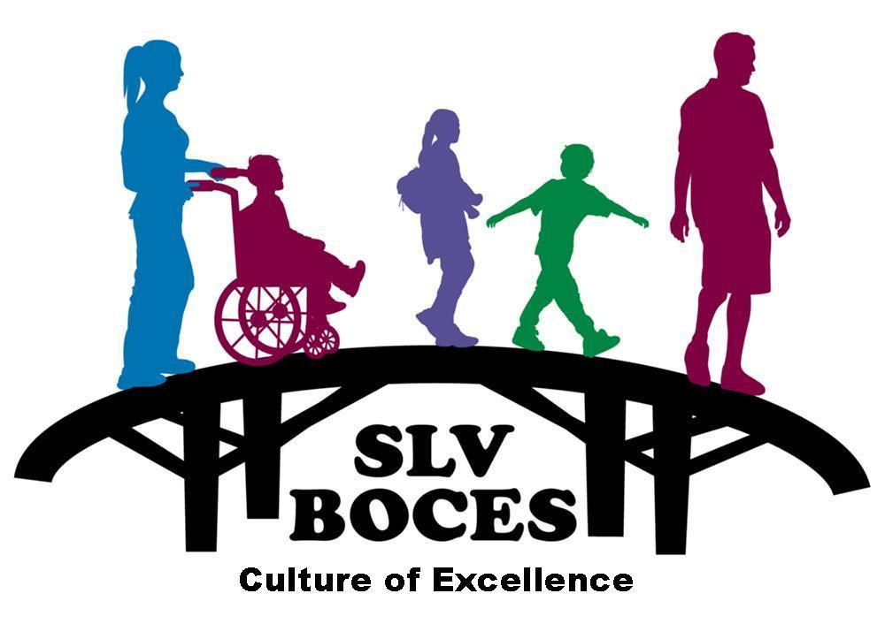

A Regional Education Agency

2261 Enterprise Dr.  Alamosa, CO  81101  (719) 589-5851

www.slvboces.org

Step By Step
Obtaining an Alternative Teacher Licensure

All alternative teachers must hold an alternative teacher license in order to participate in an alternative preparation program, regardless of whether their school/district or charter school requires them to hold a license for employment.

- First Things First …

- Submit a set of fingerprints to the Colorado Bureau of Investigation for licensure purposes by following the guidelines set forth on the CDE Web site. http://www.cde.state.co.us/cdeprof//fingerprints

- If you have submitted a set of fingerprints for the school/district or charter school in which you have obtained a teaching position, you still will need to submit a set for licensure purposes (http://www.cde.state.co.us/cdeprof/fingerprints).

- Please note: CDE cannot issue any type of credential without first receiving from CBI and FBI a cleared background check or until one of CDE’s investigators has cleared your background.

- Create an account in CDE’s eLicensing system. This will allow CDE to ensure your background checks “catch up” with you, and is the account through which you will submit all applications for educator licensure.

- Next …

- Complete and submit an application for an alternative teacher license. This is the “teacher” application in the eLicensing system. (The answers you provide (i.e., “No, I have not completed an approved teacher preparation program,” etc.) will result in your submitting an appropriate application.
- If you have not yet obtained a teacher position at the time of application, CDE will review your application to determine eligibility for participation, and then change the status of your application to “alternative licensure pending employment and program”.

Programs and districts can verify this status via their online lookup.
- If you have obtained a teacher position and include in your application a signed copy of your employment contract or hiring document(s) and a completed Statement of Assurance (aka, “SOA,” signed by your school/district/charter school and your alternative licensure program), you will be issued an alternative licensure.
- Please note: A separate application needs to be submitted for each content area for which you would like to be evaluated. That said, you may participate in an alternative program and hold an alternative licensure in one content area only.

- Finally …

- You must have your alternative teacher license in hand in order to be in the classroom. (Be sure to provide your school/district and program a copy of your alternative teacher license.)

- An alternative teacher license is valid only as long as you are actively participating in an alternative teacher preparation program. Should you withdraw or be dismissed from the program, the program will submit a Change of Status form to CDE and your alternative license will be expired.

For further information contact Nita McAuliffe at nmcauliffe@slvboces.org or 719-587-5417.

