2 or 4 year college: Skills Needed and potential Gaps identified through Annual Transition Assessment Process: Competitive Employment and Post Secondary Training:
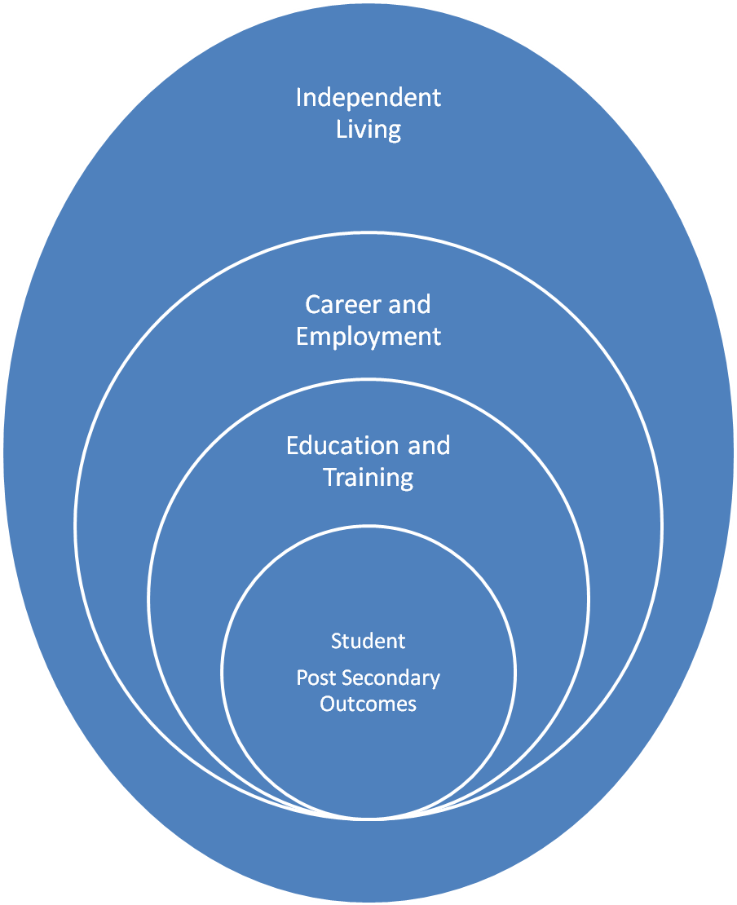

1. Employment : Ideas for specificity in Transition Services: Resource Teacher; Regular Ed Teacher; Guidance Counselor provides instruction in:
Gaining employment skills: Getting along with others using…….
to gain skills in independently being resourceful; looks for things to learn and do
to be courteous and considerate of others
to accept criticism and improve skills through practice and modeling in the classroom and transferring skills to the job shadow.
to work Fast and efficient, able to produce at employer’s expectation
reliability (Seldom wastes time) through feedback in a job shadow
in appearance, neat reviewed and practiced in life skills class
independently arriving on time (employability skill is listed as: Never tardy except for unavoidable emergencies) by self tracking arrival times and reporting the data
Completes assigned tasks by practicing task completing in …….class and self monitoring success
Developing Acceptable communication skills for requirements of post school interest through practice and modeling in…….class and opportunities to transfer communication skills in job shadow.
Follows rules and regulations of work site by obtaining feedback from supervisor on a weekly basis , reviewing with student at th end of the week successes and identifying areas for improvement.

11th and 12th grade: instruction for student to independently describe: job skill requirements of post school interest. Or realistically describe interests, talents and personal skills as they relate to fulfilling job skill requirements.
9th and 10th grade: instruction for student to describe their aptitude of job skills (written, oral, prepared to share at IEP meeting?) (what has a transition assessment informed you about your interests and ability)
2. Education and Training: Ideas for Specificity in Transition Services Resource Teacher; Regular Ed Teacher; Guidance Counselor provides instruction in:
Test taking skills: providing guidance in identifying test taking difficulties, analyzing post test skills through use of study skills checklist and utilization of anxiety control techniques; test and semester exam preparation using study tool guide; practicing test taking tips such as true false testing taking tips, tips for multiple choice test items, tips for fill in the blank and tips for matching test items in transition class and analyzing-evaluating post test results;
Note taking skills: provide instruction by completing listening activities in study tools guide (identifying listening strengths and needs, completing listening activities, recalling what you hear, completing class role plays to gain skills, practicing listen and repeat activities; completing taking notes from lecture in study tools activity guide (using symbols, abbreviations, capture important facts, using clue words); practicing taking notes by listening to a tape recorder; practice taking notes using Cornell note taking format and practice using notes to complete tests and activities.
Study skills to complete assignments, pass examinations, answer questions for group task completion, through the use of study sheet guides, memory name cards, mnemonics and visualization.; will provide instruction in study skills by using study guide to determine what information is important and memory techniques to memorize the identified pertinent information.
Listens to lectures and directions and complete tasks.
Manages time to complete assignments, projects, research papers, etc. by utilizing………(time management strategies in study skills guide –using a semester calendar-, setting goals and self-evaluating progress towards managing time based on goals and strategies utilized)
Organizes schedules, tasks, due dates, timelines, etc. through the use of………(i.e. homework assignment tracking sheet; notebook organization in study tools guide;
States/writes the educational requirements for post school outcome. (Use College in Colorado and O*Net)
Explains accommodations that support their own success
Writing skills: instruction in the writing process (5 steps, making a writing plan and outline, writing a rough draft and editing and proof reading).
Reading textbooks utilizing SQ3R method (Survey, Question, Reading, Recite, Review) from Study Tools Guide.
Explains Academic skills needed for college entrance requirements expectations or vocational setting entrance expectations and states steps and accommodations student will take to meet those requirements
3. Self Determination/Advocacy: Ideas for specificity in Transition Services Ideas for Specificity in Transition Services: Resource Teacher; Regular Ed Teacher; Guidance Counselor provides instruction in:
Describing Self Awareness (knows interests, skills, limits, strategies that work for student
Self advocacy (asks for help, asks questions, states needs, stands up for self, knows rights, has skills to self disclose regarding disability and accommodations); instruction in self advocacy to complete Who Are You and role playing answers in scenarios to practice advocacy skills;
Self-efficacy (knows they can accomplish goals, believes in self): in setting goals and self-charting progress in attaining goals and reflecting on outcomes—what did I do well, what could I do better? ; in creating a plan and coming up with strategies to complete the plan to be successful in …..academic tasks; learning to communicate on own behalf, stating preferences, alternatives, expressing needs or accommodations that assist student in meeting academic tasks; preparing and presenting for IEP meeting; utilizing LUCK strategy to manage differences of opinion through role play and practice and practicing asking questions when student doesn’t understand—what are appropriate concerns and questions for various settings.
Makes decisions for self (sets goals, makes choices)
Independent performance (initiating and following through on tasks without undue assistance)
Self-evaluation (able to reflect on the success of efforts and able to adjust and make changes)
IEP Process teaches the following when planned into and supported by daily educational experience:
- Choosing mediums to communicate progress (graphing, writing, pictures/video, drawing)
- Paraphrasing technical language
- Reading and writing in context
- Using technology such as presentation software and word processing
- Introducing people, sharing ideas with people,
- Stating the main idea
- Thinking and planning for the future (vision)
- Taking turns and inviting others to speak
- Listening and responding with a relevant and appropriate answer
- Asking relevant, proactive questions
- Advocating-stating opinions, backing with data
- Using presentation skills
- Compromising, Teaching consensus/Proposing compromise solutions
Hawbaker, B.W. (2007). Student-led IEP meetings: Planning and implementation strategies. TEACHING Exceptional Children plus, 3(5) Article 4. Retrieved 6.6.2008 from http://escholarship.bc.edu/education?tecplus/vol3/iss5/art4
4. Daily Living: A. Document assessment that indicates no daily living needs or B. Ideas for specificity in Transition Services. Resource teacher; Transition Teacher; Guidance Counselor will provide instruction in:
managing a budget to meet needs from paycheck to paycheck, pay bills, balance a check book, understands interest rates and banking—savings, retirement, etc.
in gaining skills to do Laundry, Planning meals, cooking meals and clean up, Cleaning house, Daily hygiene
learn about and meet transportation needs
Knows and understands daily living arrangements such as finding an apartment, dorm, house, etc.
5. Interpersonal Relationships and Communication; Ideas for specificity in Transition Services
Identify and express feelings
Distinguish between appropriate and inappropriate behavior
Recognize personal boundaries, rights and privacy needs
Understand the need for self-control and how to practice it
Demonstrate cooperative behavior in groups
Knows how to make and keep friends
Learns/knows how to cope with peer pressure
Learns/knows how to manage stress and conflict
Conveys messages in writing, handwritten, typed, computer.
Demonstrates keyboarding skills, can send and receive emails, etc.
Communicates verbally to a variety of audiences, adapting to needs of listeners
Listens to other perspectives,
6. Leisure Activities, Community Participation, Health: Ideas for specificity in Transition Services
Accesses entertainment, knows activities in line with entertainment of interest
Participates in community events (religious, leisure, etc.)
Knows about voting, voter registration,
Can schedule appointments, read prescriptions’, take medication, knows what to do when ill

