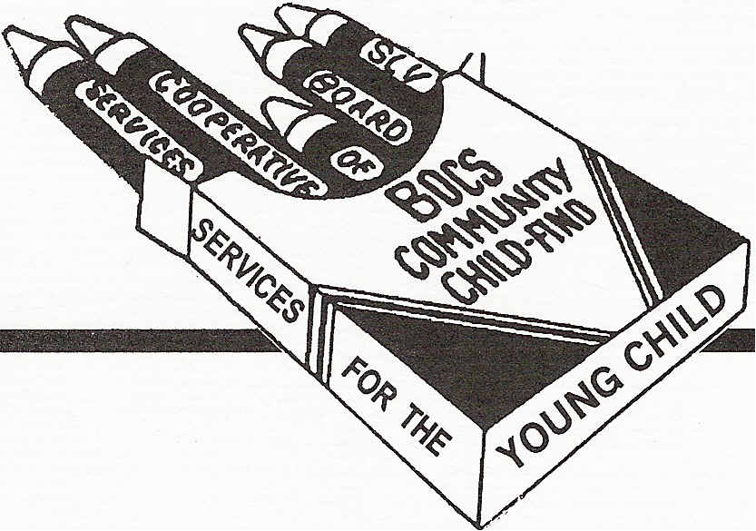
SAN LUIS VALLEY BOARD OF COOPERATIVE SERVICES
Child-Find
2261 Enterprise Drive. Alamosa, CO 81101 589-5851 FAX : 589-5007

Date _______________________________
Child's Name _______________________________________ M/F:_____ DOB: ___________
First, Middle, Last
Parent (s) Name _______________________________________ Phone ________________________
Home Address ______________________________________ City ________________________________
Mailing Address _____________________________________ City ________________________________
Child Attends: Head Start: ______________ Preschool: __________ Childcare:___________________

Referring Person ____________________________________ / _____________________________________
Name and Organization FAX, e-mail or mailing address: required if requesting
follow-up information on referral.
Child's Physician ________________________________________
Reason for Referral ______________________________________________________CAPTA? __________
Language spoken in the Home ____________________Interpreter needed? ___________________________
Other Information (If screening(s) have been done, please attach copies of results.)
__________________________________________________________________________________________ __________________________________________________________________________________________
I authorize Child Find and/or Blue Peaks Early Intervention to share information related to this referral and follow-up with: (Not required for referral): ____________________________________________________
___________________________________ _________________________
Parent Signature (not required for referral) Date
Update to Referral Source for children aged 3+ (if release received). Blue Peaks: (719) 589-5135 will provide follow-up on children referred aged 0-3.
Passed Developmental Screen Family declined Child Find screening or evaluation.
No response from family after multiple attempts to contact.
Child evaluated on ________________: Outcome: Not eligible for Preschool Special Education at this time.
Eligible for Preschool Special Education; (Circle): PT OT ST Cognitive Social Emotional
BOCES OFFICE USE ONLY
Date Recv'd ________________________ Please return this referral to:
By ________________________________ Child Find Coordinator
Notes ______________________________ San Luis Valley BOCS
___________________________________ 2261 Enterprise Drive
Alamosa, CO 81101 (719) 589-5851
FAX: 719 589 5007

