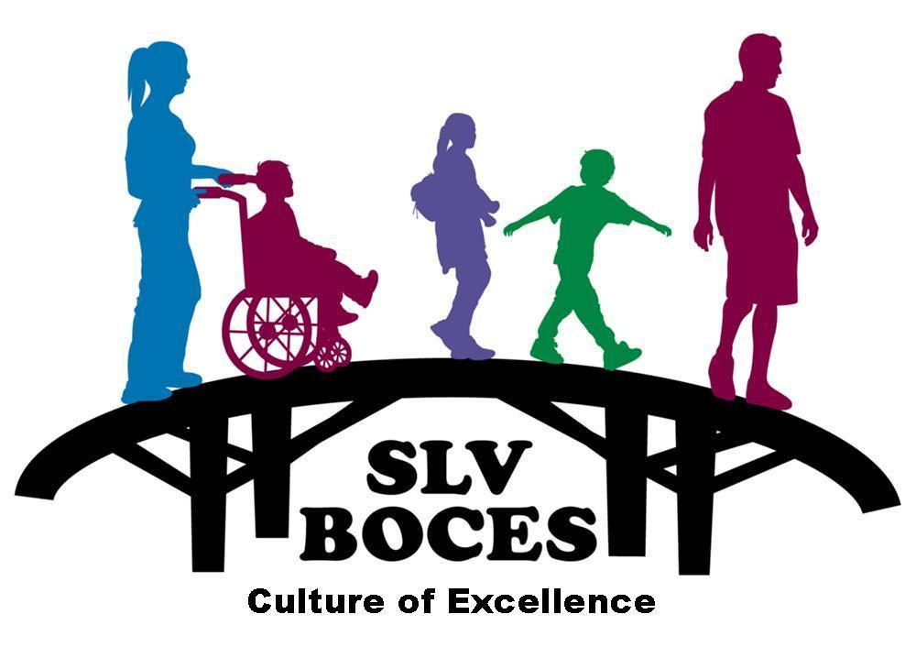

A Regional Education Agency

2261 Enterprise Dr.  Alamosa, CO  81101  (719) 589-5851

www.slvboces.org

Date

Dear Parent(s)/Guardian(s):

Your child ________, performance and behavioral characteristics indicate that he/she should be screened to determine how we can best meet your child’s educational needs. This screening involves gathering the following information:

- Achievement - demonstrated by test scores
- Behavior/Characteristics – observation of behaviors or motivation as seen by teachers and parents
- Demonstrated Performance – as evidenced by portfolios or competition participation
- Intellectual Ability - information from a norm-referenced standardized cognitive test

To gather evidence of intellectual ability we would like to give your child a test of cognitive ability. This will be done at the school. Please sign the attached permission slip to allow this test and any other necessary testing to be given to your child and return it to ___________If you have any questions about the testing contact me at _____________.
The final piece of the screening will be to gather information from you using a questionnaire. This will help us assess your child’s strengths, weaknesses and needs.
After the information is gathered it will be reviewed by the RTI team and we will consult with you to determination to how to program for your child.

Sincerely,

Name
Coordinator of Gifted Education
___________School District

